Candidate Information Pack


PRINCIPAL PLANNING OFFICER

A Message from the Head of Planning

Thank you for your interest in this role for the Council. This is a fantastic opportunity for an exceptional individual with the drive and talent for delivering exciting planning projects within Surrey Heath Borough Council.

I wanted to let you know that alongside our clear ambition, we are also a friendly and collaborative organisation where our staff feel really proud of the work that they do and the difference they make every day to the lives of our communities. This makes Surrey Heath a very special place to work.

I hope in the pages below we are able to give you a flavour of what Surrey Heath has to offer. If this excites your interest, I would be delighted to receive your application.

Best wishes,

Gavin Chinniah
Head of Planning
Surrey Heath Borough Council


Surrey Heath
Situated in North West Surrey, with a population of 88,000, Surrey Heath is a beautiful place to live and work. We rank first in the Home Counties for wellbeing (NOMIS 2019) and first in England and Wales for tree coverage (Bluesky). Combine that with close proximity to London and our ambitious regeneration programme for Camberley town centre (the Borough’s largest town), and we have a lot to offer.

The borough covers 36.5 square miles in north west Surrey, on the border of both Berkshire and Hampshire and is a contrast of urban and rural environments. The area has unique military heritage with the Royal Military Academy Sandhurst, where all Officers in the British Army are trained, and Deepcut Barracks.

Generally an affluent area, people who work here have the second highest average weekly wage in the South East. But having enough homes for people that need them and are affordable is a challenge when balanced against the need to maintain the green nature of the borough and the extensive specially protected heathland (SPA).

We know a number of our residents and their families that are struggling, a situation made more challenging by the Covid-19 pandemic. In some parts of the Borough there is a life-expectancy gap of up to 11 years and with the number of older people expected to rise more in Surrey Heath than other places over the next five years, we have to re-focus our priorities.

This is a uniquely challenging time for local businesses, therefore a strong economy and vibrant town and village centres are vital for local employment and future business success. The Council has invested significantly over recent years in Camberley town centre. We will continue our work with our towns, villages and rural communities to make these areas attractive to businesses and visitors.

About Surrey Heath Borough Council
We are one of the smallest Boroughs in the country with 35 elected members, currently in no overall control and 250 staff with a strong ethos for public service.

We recognise that nothing can be achieved in isolation, and we have a strong foundation in Surrey Heath of partnership working.

Our emerging Medium-term Financial Strategy (MTFS) includes a cumulative budget gap of over £6 million over the next four years. We have an excellent track record of financial management and during almost a decade of austerity and cuts in Local Government funding, Surrey Heath has managed to protect frontline services and continue to invest in priority initiatives. However, during the same period the Council’s budget has had a growing reliance on income from commercial rents including rents from the retail sector, which can no longer be sustained at previous levels.

We are committed to taking action on climate change, helping the increasing number of people who find themselves in poverty in Surrey Heath and increasing our focus on the health and quality of life of our residents. This means more investment to support our vibrant villages and rural communities, alongside our continuing improvements to Camberley town centre.

The Council is developing a new Five Year Strategy through extensive engagement with residents, businesses and partners under the emerging themes of Environment, Health & Quality of Life, Economy and being an effective and responsive Council.

These build on key priorities for the organisation including: Supporting the economic recovery and the recovery of our communities; Delivery of a programme of regeneration including delivering a return on the Council’s property holdings; Supporting community and voluntary organisations and their volunteers; A greater focus on partnership working and collaboration; The urgent need to protect the environment and tackle Climate Change; Contribute to the physical and mental health and wellbeing of our communities; Tackling poverty, diverging mortality rates and other inequalities that exist within our communities; Place shaping – including the development of a new Local Plan, supporting and strengthening our town and village centres, and the delivery of more affordable housing; increasing enforcement activities and tackling anti-social behaviour; Achieving a balanced budget and investing in the future. Our work is underpinned by effective project management and delivery, excellent customer service and meaningful community engagement.

Recent Project Success
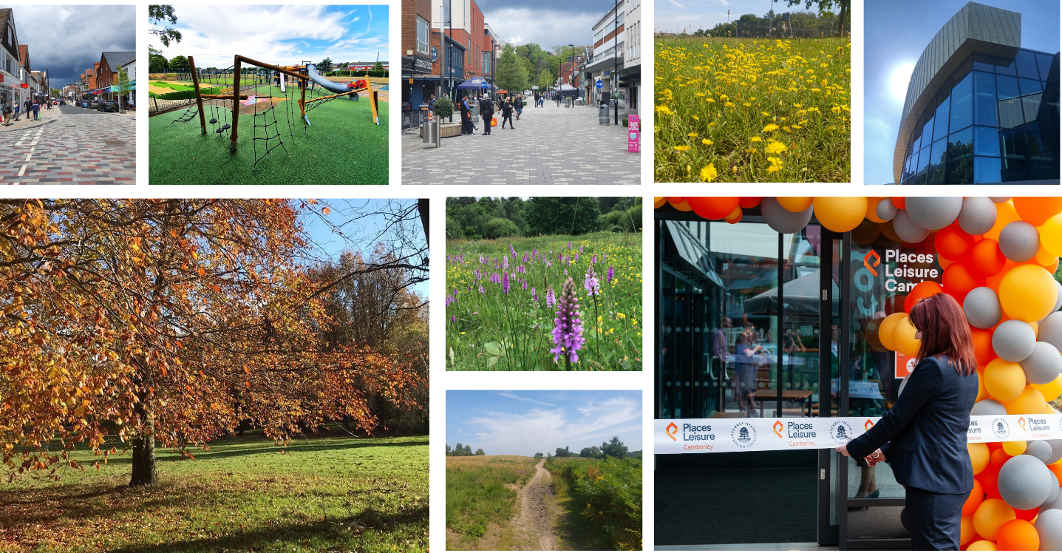

Camberley Town Centre – Regeneration and Public Realm
The Council is committed to supporting and regenerating Camberley. SHBC’s investments have already seen the acquisition of The Square shopping centre, commencing its refurbishment programme within the first year of ownership. Followed by an ambitious set of projects to improve the roads, pavements and street scene in the town centre including the installation of public art which following public engagement workshops. A redundant office building has also been purchased to create 116 high quality town centre apartments, with proposals to re-deliver new commercial space. As well as the rebuild of a new multi-million pound leisure centre the Council continues to develop plans for a 5.5 acre multi-use development site opposite the Royal Military Academy Sandhurst.

New multi-million pound leisure centre opened in Camberley
A multi-million pound, state of the art leisure centre opened in Camberley at the beginning of July 2021. The centre was successfully constructed throughout the pandemic despite the enormous challenges faced by the construction industry. The centre features a cutting edge fitness suite – equipped with the latest workout machines and apparatus, 25 metre 6-lane pool, learner pool with adjustable floor, splash zone (interactive water confidence area), eight court sports hall, group exercise studios, health suite, temperature controlled yoga studio, immersive cycling studio, a vibrant Clip 'n Climb climbing arena and a Costa Coffee Café. A fun purpose-built adventure play area is also available for families to enjoy.

Sixth highest recycling rate in the England
The latest recycling figures show Surrey Heath was ranked sixth in a list of English councils with the highest household waste recycling, compost and reuse rates in 2019/20.

The impressive result in Defra’s Local Authority league table reveals Surrey Heath’s recycling rate increased by 1% from last year, taking it to 62.9%. which was just 1.2% below the top performing English authority. At a local level Surrey Heath was the top recycling area in Surrey.

Award winning Parks and more trees than any other Borough
There are two premier parks in the Borough, both hold the prestigious Green Flag. Frimley Lodge Park attracts a large number of visitors with its beautiful open spaces, picnic areas, pitch and putt course, newly refurbished children's playground; as well as a miniature railway, barbecue and private hire areas. There’s also a 3G all-weather football pitch, traditional football and cricket pitches, and a café.

Lightwater Country Park is predominantly heathland habitat, but there are also ponds, woodland, meadows and areas of scrub providing essential habitats to a wide variety of wildlife, birds, mammals, plants and insects. The area of heathland within the Country Park has been designated a Site of Special Scientific Interest.

The park also offers a café, new children’s playground, information point, educational service, walking trails, grazing livestock, bee hive and fishing.

We’re proud of our status as the Borough with the most tree coverage in the whole of England and Wales.

Relationships with our partners
Positive and effective partnership working is a hallmark of Surrey Heath’s approach to delivery, including our latest partnership with Runnymede for the operation of our wellbeing services such as community transport, our wellbeing day centre, telecare and meals at home.
But it is not only our partnership with other Councils that sets us apart. During the Covid pandemic we helped galvanise over 2,000 volunteers, who stepped forward to help others in their communities. 80% of our staff were redeployed in some way to our welfare response –stepping out of their normal roles and ‘comfort zones’ to protect and support the most vulnerable in our communities. The Council supported the NHS by taking all vaccination phone calls and helping residents book appointments to ensure our communities were kept safe.

What our staff say…
“Surrey Heath Borough Council has helped shape me into the person I am today, and with continuous support and opportunities, I am confident my career will only flourish here.”
“I would strongly recommend Surrey Heath Borough Council to anyone.”
“The friendly atmosphere allows for a non-judgmental and positive experience and I believe the Council does well in fostering collaborative working across departments.”
“It is an exciting time to be joining Surrey Heath Borough Council as we develop our ambitions for the next five years, put in place new strategic partnerships and start delivery of a range of exciting new initiatives.”

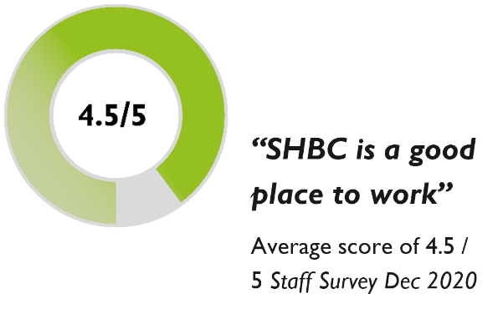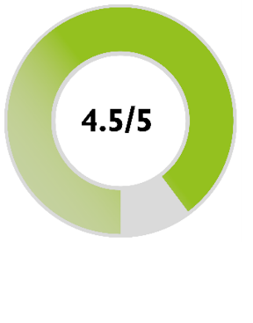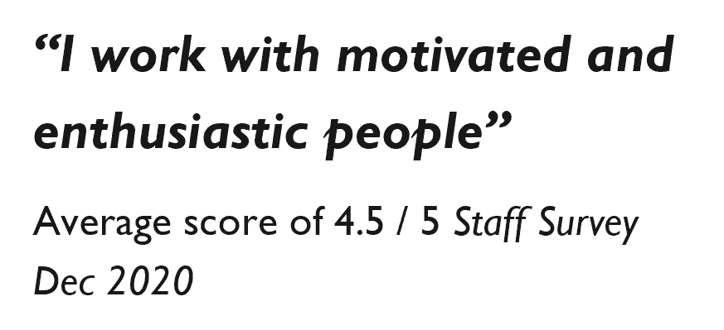

Our ethos is to invest in our staff; offer opportunities to individuals to grow and develop their skills and nurture our talented people. Our training and development for staff includes; A well development talent-management approach including apprenticeships, hugely successful internship programme and Local Government Association National Graduate Development programme; Internal mentoring programme; Surrey Learn Partnership providing excellent personal development opportunities; Management development programmes for aspiring, new and experienced managers; Significant investment in staff qualifications and career paths via the ‘Post entry training’ scheme and a wide range of e-learning, including mandatory and induction training.
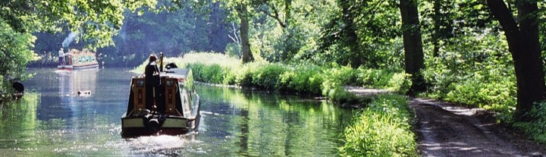

The Role
Dissected by the M3 Motorway, Surrey Heath is diverse and in addition to urban and town locations contains significant green belt land, countryside and rural settlements, conservation areas, sites of nature conservation importance and land liable to flood. The borough is constrained by the Thames Basin Heath Special Protection Area and is the most treed borough in the UK. With excellent links to London, Surrey Heath is an attractive place to work and live. This is a challenging time for the Council with the Local Plan review, regeneration opportunities within Camberley Town Centre, commercial interest with international companies investing in the borough, and significant new housing developments at Deepcut and throughout the borough.
An exciting opportunity has arisen for an experienced planner. This role will include dealing with a variety of planning applications, comprising a mix of delegated and committee applications. The successful candidate will be expected to deal with applications for major developments, which may require extensive pre-application discussions and hard negotiation on complex issues and will be expected to represent the Council on appeals.
The successful applicant will:
- Possess good technical knowledge of development management
- Have demonstrable experience working on a wide range of planning applications
- Have experience of working on major developments
- Have experience of presenting at committee
- Be a highly motivated person, possessing ambition and drive
- Be able to positively influence outcomes by working effectively with developers and applications
- Be able to handle pressure and competing interests

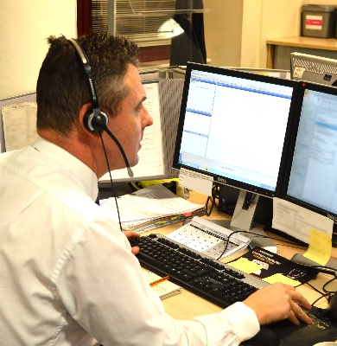
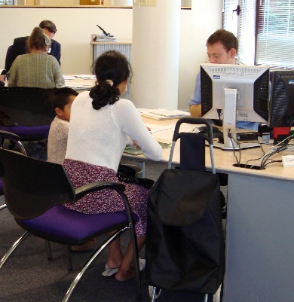
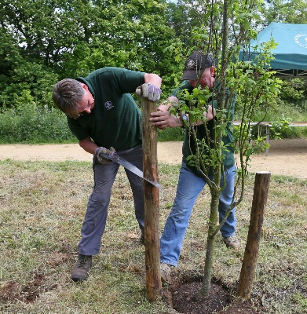

How to apply

Applications
Applications are to be completed online and submitted no later than 4th October 2021. CV’s can be submitted via the online portal but cannot be accepted without a completed application.
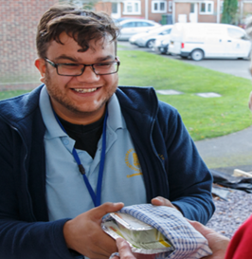

Appointment Information

Salary
The salary grade for the post is SH7 and the incremental points are:

Scale Point | Salary (£)
7.28 | 40,673
7.29 | 42,104
7.30 | 43,531
7.31 | 44,932
7.32 | 45,500

All incremental progression within the grade is related to the performance of the post holder in accordance with the Council’s Performance Management Scheme. All performance related changes are effective from 01 April of each year.

Annual leave
The post carries an annual leave entitlement of 25 days. After 5 years’ continuous Local Government service, you will be entitled to an additional 5 days’ annual leave.

Pension
All Surrey Heath employees who under the age of 75 and have a contract of employment for at least 3 months will automatically become a member of the Local Government Pension Scheme (LGPS) on their first day of employment, unless they opt out of the scheme upon joining the Council. You will be required to pay the relevant contributions to Surrey County Council LGPS. Further information on LGPS can be found on Surrey County Council Pension website https://www.surreypensionfund.org/

Benefits
The Council recognises that its main asset is its staff. In recognition of this the Council offers a generous benefits package which is currently as follows:
- Local Government Pension Scheme.
- A minimum of 25 days annual leave entitlement (pro-rata for part-time employees).
- An additional 5 days annual leave after 5 years continuous Local Government service.
- Free private medical insurance for all staff after three years continuous service at Surrey Heath Borough Council.
- Three times salary Life Assurance cover for all staff in the Pension Scheme.
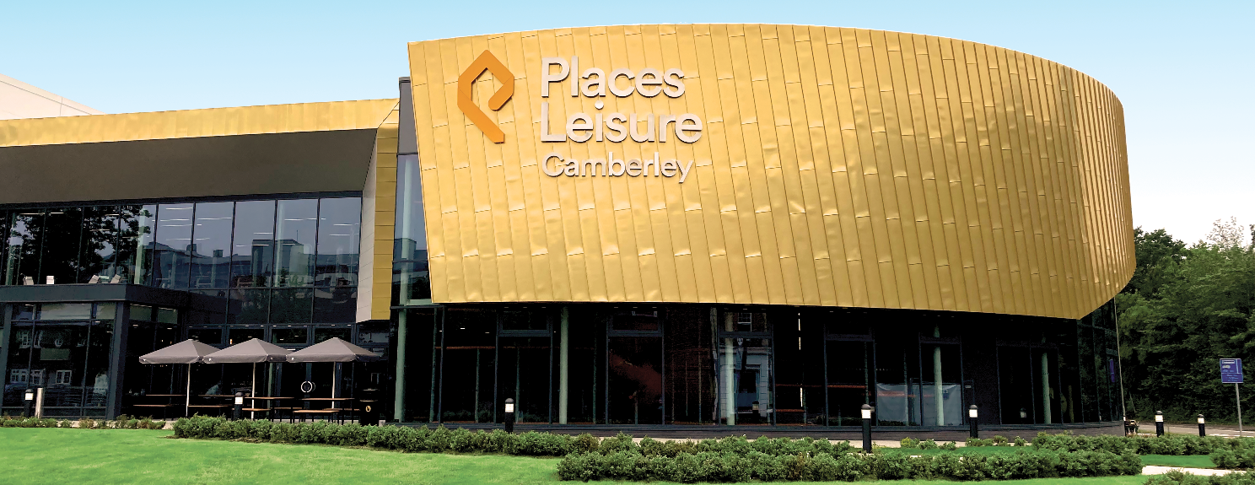
- Free parking for all non-casual staff.
- Regular health checks and other welfare initiatives and health promotions.
- Subsidised gym membership.
- Employee Assistance Programme (EAP).
- Free VDU eye examinations every 2 years.
- Free vaccinations when / where appropriate.
- Access to reduced travel insurance.
- Staff uniforms where required for all appropriate employees.
- Flexible working policy.
- Commitment to regular learning and development linked to Corporate objectives and support for professional learning and development, where appropriate.

Organisation Chart
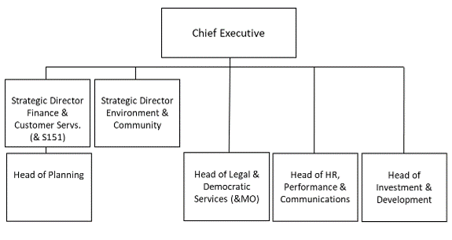

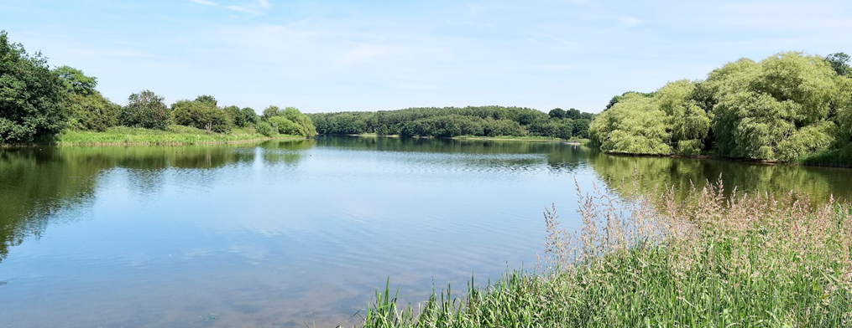

Job Profile

Principal Planning Officer
Responsible to: Development Management Team Leader, Development Manager
Services: Regulatory
Location: Council Offices. Surrey Heath House, Camberley

Main Purpose of Job
- Process a variety of planning applications comprising a mix of delegated and committee applications, particularly major applications
- Process pre-application enquiries
- Prepare sound planning reports
- Present applications to Planning Applications Committee and answer detailed enquiries
- Provide guidance and direction to Planning Officers and Assistant Planning Officers on more complex applications within their caseloads and to assist with sign off of work
- Undertake appeals by written representations, hearings or public enquiries

Responsibilities
- Provide expert advice to applicants, developers, agents, and specialist consultancies through pre-application advice, and be able to negotiate on planning proposals
- Assess a wide range of planning applications, in particular more complex and major development proposals
- Understand the formal and informal processes necessary to undertake planning enforcement and compliance work and be able to apply expediency tests and planning judgement to the more complex enforcement cases
- Compile clear, concise and proportionate reports which having regard to all material planning considerations demonstrating a consistency in approach, with fully justified and precise conditions or reasons for refusal
- Defend the Council’s reasons for refusing planning applications and take enforcement action via written representations, hearings and public inquiries
- Supervise other officers with their caseloads
- Meet statutory targets and deadlines, be well organised and minimise the risk of complaints or claims against the council
- Attend Planning Applications Committee on a regular basis to present applications

Creativity & Innovation
- The post holder will need to have a sound understanding of planning law and circular guidance, and employ this to negotiate hard for enhanced planning solutions when involved in difficult, complex and detailed pre-application discussions with developers and agents
- Will need sound time and project management skills to determine major planning applications in a timely and effective manner
- Will be an idea person and contribute to assisting the Development Manager with amending internal procedures and improving efficiencies

Impact upon the Organisation & the Community
- Large planning applications have a considerable impact on internal officer resources and the experience and expertise of the post holder will be applied to minimise wasted efforts seeking to resolve complicated planning issues which the larger applications can often present
- Large planning applications are likely to be those which impact beyond the immediate locality
- Large planning applications are likely to raise resources issues for other Borough Council services, these must be identified and assistance given to the Development Manager in ensuring that these are addressed

Management & Supervisory Responsibilities
- Will supervise staff as the need arises and in consultation with the Team Leader and Development Manager
- Will deputise for the Team Leader as the need arises
- Will provide a support role to Planning Enforcement

Relations with People (Internal & External)
- Must be able to work well with the Development Management Team Leader and planning officer, enforcement officers and arboricultural officer
- Will need to develop effective working relationships with Councillors, explaining complex planning issues, both informally on a regular basis helping Councillors deal with enquiries they have received, and formally at Planning Applications Committee
- Will need to develop effective working relationships with other development management planners, planning policy officers, arboricultural officer, heritage advisers, biodiversity advisers, noise and pollution advisers, drainage and flooding advisers, housing needs advisers, agricultural viability advisers, legal advisers, and other specialist advisers

Important Internal Relationships
Councillors, Development Manager, Development Management Team Leader, Planning Policy and Support Manager, Planning Policy and Conservation Officers, Drainage Officer, Legal, Environmental health contact centre, Technical Support and Land Charges Manager, Green Space team, Housing Manager

Important External Relationships
Planning Inspectors, Natural England, English Heritage, Environment Agency, Thames Water, Surrey County Council, Surrey Wildlife Trust, Developers, Planning Agents, Specialist consultants, landowners, MOD/Defence Estates, Housebuilders, businesses and business groups and organisations, Parish Councils, residents and amenity groups, other local authorities

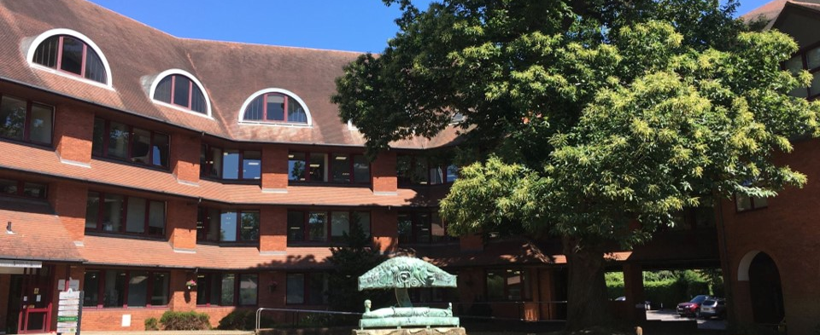
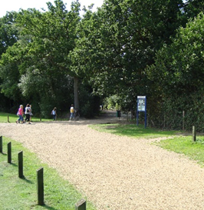
Person Specification

Qualifications and Training

Essential
- Degree in Town and Country Planning/Urban and Regional Planning, or equivalent
- Member of the Royal Town Planning Insititute
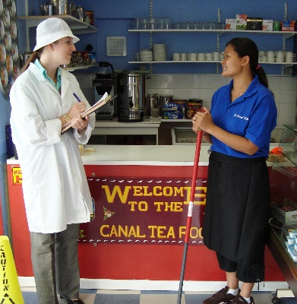

Desirable
- Qualifications in related areas

Knowledge and Experience

Essential
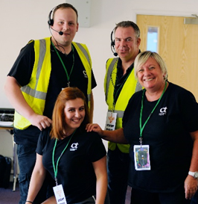
- Excellent working knowledge of planning legislation, national planning policies and planning reforms
- Experience in a wide variety of planning work, which must include a mix of planning applications
- Significant experience of handling major applications and appeals which present complex planning issues
- Good working knowledge of performance management techniques
- Understanding of CIL and the section 106 process
- Excellent IT skills.
- Experience of planning enforcement
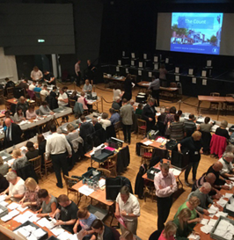

Desirable
- Good training record in planning areas of work
- Experience and skill in presenting issues to formal meeting and/or public inquiries

Relations with People (Internal & External)

Essential
- Need to develop effective working relationships with internal staff and councillors
- Need to be able to network confidently with external agencies, including Parish Councils, Statutory consultees, Surrey County Council and others

Creativity and Innovation

Essential
- Need to employ strong negotiating skills drawing upon accumulated planning experience and expertise to help resolve difficult planning issues
- Ability to craft planning reports which skilfully and concisely identify key determining issues and demonstrate the application of sound planning judgements, dealing with matters of principle and detail
- Ability to look holistically at processes and develop these to reflect changed circumstances and efficiency opportunities
- Able to project manage handling of large applications to identify other service/organisational input required in a timely and effective manner

Management and Supervisory Responsibilities

Desirable
- Ability to share and impart planning expertise on complex planning issues to other staff and to coach and counsel where appropriate
- Previous staff supervision experience

Initiative and Independent Action

Essential
- Ability and confidence to take day to day decisions without referral to the Team Leader
- Able to judge when more complex or highly politicised issues need to be discussed with managers
- Able to manage the day-to-day interactions with other individuals and organisations

Personal Attributes

Essential
- Good communication skills
- Ability to persuade and motivate others
- Good team player
- Flexible outlook and ability to manage change
- Good negotiation skills
- Self-motivated and able to drive forward projects
- Full valid driving licence

